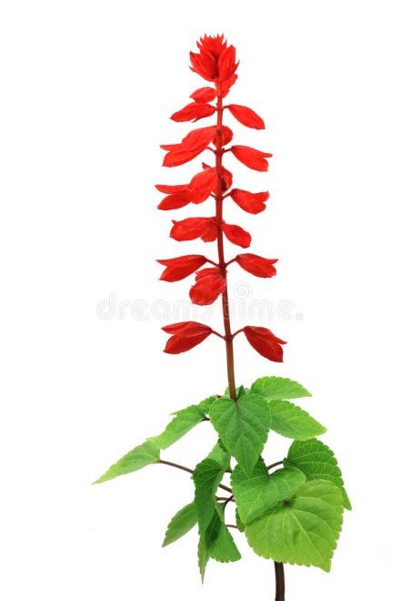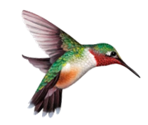

**Plants Today – June 8, 2018**

**Attracting Hummingbirds**

***Salvia splendens* 'Red Hot Sally'**

This tender perennial native to Brazil is typically grown as an annual in our climate and is attractive to bees, butterflies and hummingbirds. Red Hot Sally produces spikes of vivid red flowers early in summer through frost - Trim off spent flower spikes to encourage more flowers.

This red sage cultivar needs full sun and average garden soil but is very heat and drought tolerant once established.

Brightly-colored tubular flowers that hold the most nectar are highly attractive to hummingbirds. Some good plants for attracting hummingbirds include:

* Lobelia
* Bee Balm
* Penstemon
* Salvia
* Honeysuckle
* Agastache
* Zinnia
* Eastern Red Columbine
* Foxgloves
* Hollyhocks



**Plants Today – June 8, 2018**

**Attracting Hummingbirds**

***Salvia splendens* 'Red Hot Sally'**

This tender perennial native to Brazil is typically grown as an annual in our climate and is attractive to bees, butterflies and hummingbirds. Red Hot Sally produces spikes of vivid red flowers early in summer through frost - Trim off spent flower spikes to encourage more flowers.

This red sage cultivar needs full sun and average garden soil but is very heat and drought tolerant once established.

Brightly-colored tubular flowers that hold the most nectar are highly attractive to hummingbirds. Some good plants for attracting hummingbirds include:

* Lobelia
* Bee Balm
* Penstemon
* Salvia
* Honeysuckle
* Agastache
* Zinnia
* Eastern Red Columbine
* Foxgloves
* Hollyhocks